Thermal 360 Instructions
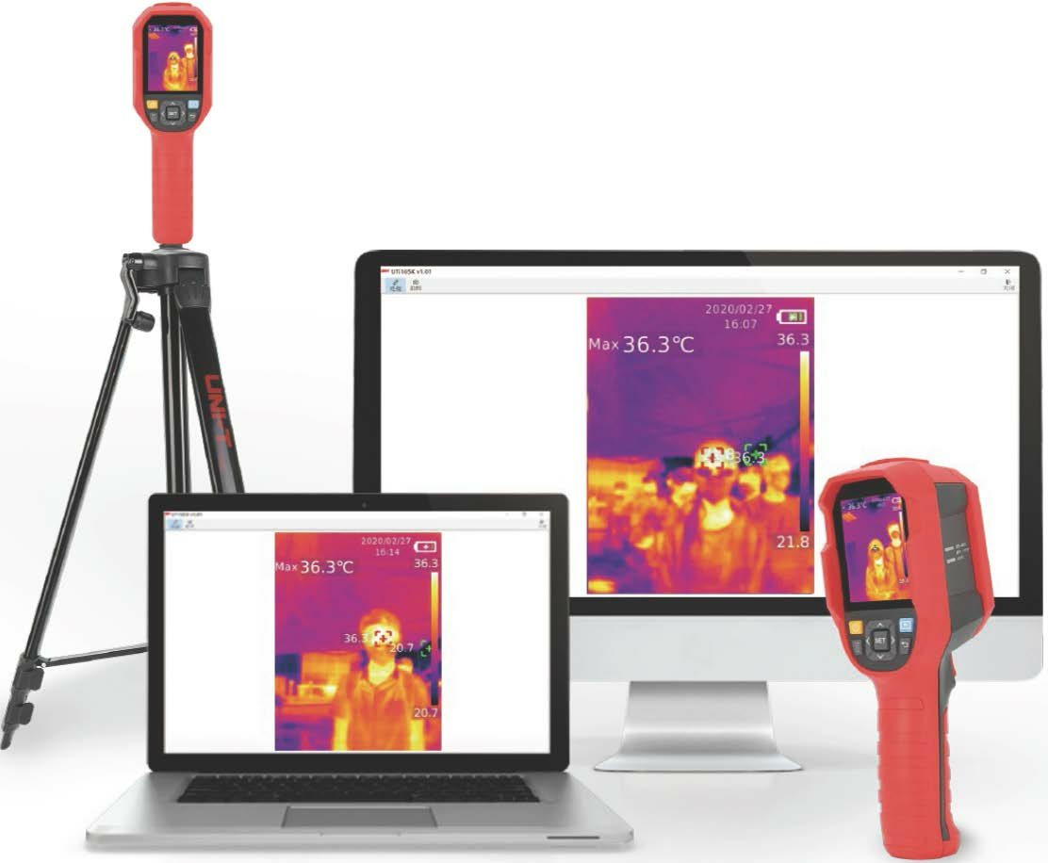

Contents
1. Safety, Prohibit and Legal Notices. 4
1.1 Copyright 4
1.2 Disclaimer 4
1.3 Safety notes. 5
1.4 Legal notes. 6
2. General Design. 7
2.1 Display. 8
3. Menu 8
3.1 Turn ON / OFF 8
3.2 Measurement 9
3.3 Palette 9
3.4 Point Temperature 9
3.5 Image Mode 10
3.6 Settings 10
3.6.1 Language 11
3.6.2 Date and Time 11
3.6.3 Temperature 11
3.6.4 HI/LO Temperature Alert 11
3.6.5 Measurements 11
3.6.6 Display Brightness 12
3.6.7 Auto Power Off 12
3.6.9 Auto Save 12
3.6.10 System Settings 12
4. Operating Instructions 14
4.1 Image Capture 14
4.2 View Image 14
4.3 Temperature Compensation 15
4.4 Flashing/Warning Lights 15
4.5 USB Communication and Image Projection 15
4.6 SD Card 15
4.7 Charging 15
5 INSPECTION and MAINTENANCE 16
6. Common Emissivity. 16
7. Warranty 16
8. AFTER-SALES SERVICE 16
9. SPARE PARTS 17
9.1 Recommend Spare Parts 17
10. TECHNICAL SPECIFICATIONS 17
11. References 18
11.0 ESP documents 18
11.1 Statutory documents 18
11.2 Abbreviations 18
11.3 Definitions 18
11.4 Requirements owner 19
11.5 History 19
APPENDIX A – CE Certificate 20

1. Safety, Prohibit and Legal Notices.
Thank you for purchasing the Evolve Thermal image 360 gun. To use this product safely and correctly used, please read this manual thoroughly, especially the safety instructions and the following environment conditions. After reading this manual, it is recommended you keep the manual at an easily accessible place, preferably close to the device.

The Thermal 360 is a non-contact device for temperature measurement, it determines an object’s surface temperature by measuring the amount of infrared energy radiated by the object’s surface.

Resellers, integrators, installers, specifies and owner/occupiers of premises intending to use this device are strongly advised to establish predicted user characteristics and precise operational requirements such as: -
- The volume of pedestrian traffic at different times of the day.
- Installation environment.

1.1 Copyright
This document and information which it contains remain the property of Evolve Security Products (ESP) at all times and must be returned immediately upon request. The information contained within this document is confidential to ESP and may not be passed to any Third Party without prior written permission from ESP.

The copyright of this manual remains the property of ESP at all times. This document may not be transmitted or reproduced by any means without prior written permission from ESP.

Every effort has been made to ensure that the information contained within this document is correct at the time of supply. In no circumstances will ESP be responsible or liable for any costs, damage or injury whatsoever arising from the use of this document.

The document is subject to revision without prior notice.

1.2 Disclaimer
Thermal image devices are not intended to diagnose or monitor any medical condition or illness. These products are supplied as a first line defense for organisations that wish to identify and check people’s temperature entering their buildings. It is down to the organisation to determine how that information is used, and the appropriate reaction to take.

Environment conditions - When used to detect body temperature it is important to find the best working environment. Thermal Imaging cameras are deigned to pick up hot heat sources and can give confusing results when a surface reflects heat from an adjacent source such as windows, mirrors, shiny materials, electrical item such as a mobile phone, PC, Monitor, electrical cable and other heat sources such as water pipes, radiators under-floor heating, and direct sunlight.

1.3 Safety notes.
Resellers, integrators, installers, service providers, specifies and owner/occupiers of premises, MUST adhere to these safety notes.

 | Do not use the product in places with strong sunlight or electromagnetic interference.
 | Please do not use the product in flammable, explosive, steamy, wet, or corrosive environments.
 | Please use the product indoors without wind.
 | Please stop using the product if it is damaged or modified to avoid inaccurate measurement results
 | Please use the correct emissivity to obtain accurate temperature readouts.
 | When the flashlight is on, please do not point to the eyes of people or animals.
 | This devise must not be pointed at the sun or other intensive sources of radiation (e.g. objects with temperatures exceeding 200 °C). This can lead to serious damage to the detector.
 | To avoid damaging the device, protect them from EMF (electro-magnetic fields) such as arc welders, induction heaters, static electricity, thermal shock caused by large or abrupt ambient temperature changes
 | After the product starts this shutdown procedure which takes 5 to 6 seconds. Please try to avoid turning on and off the to avoid damaging the device.
 | This device uses flashing LED lights.
 | To ensure accuracy of the product, please warm it up for 10 to 15 minutes before measuring if it has not been used for a long time.
 | When being charged, the internal temperature of the product rises, which will lead to inaccurate temperature measurement. So, it is not recommended to take measurements during or right after charging the product
 | The optimal measuring distance for this product is 1mt.
 | To ensure measurement accuracy, please use the product in an operating environment of 15°C~30°C, <85% RH (non-condensing).
 | When changing to a new environment, please turn on the product and leave it for 10 to 15 minutes before measuring.
 | The ambient temperature for measuring must be stable. Do not measure in places with large airflow such as fans and air outlets.
 | When the measured object comes from a place with a large temperature difference from the measurement environment, keep it in the measurement environment for 10 to 30 minutes before measuring
 | The product tests the surface temperature of the object. If temperature compensation is needed, please adjust in the Settings menu.
 | The product has a self-calibration function. If the reading jumps quickly, please read the temperature after it gets steady.
 | After measuring extremely high or low temperature objects, please leave the product for 10 minutes before next use.
 | ESP cannot be held responsible for any damage or injury resulting from the improper use of the gates.
 | Do not install this equipment in an explosive area.
 | To avoid the risk of voiding the warranty use antistatic gloves or bracelets when handling electronic components.
 | Do not add unapproved accessories.

1.4 Legal notes.
Resellers, integrators, installers, service providers, specifies and owner/occupiers of premises, MUST adhere to these legal notes.

In the event of resale of the equipment, it is the responsibility of the seller to ensure
- That a copy of the safety notices are provided to the purchaser.
- That a copy of the installation manual is provided to the purchaser.
- That the equipment’s foreseeable environment, user and technical characteristics of the site are meet by the equipment.
The re-seller shall defend and indemnify ESP from any claims which may be raised against ESP due to the seller’s failure to comply with the legal and safety notices.

2. General Design.

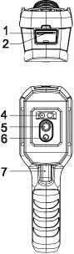
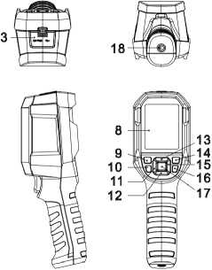

Item | Description | Item | Description
1 | USB (Type-C) interface | 10 | Flashlight button
2 | SD card slot | 11 | Left button
3 | Interface cover | 12 | Down button
4 | LED light | 13 | Up button
5 | Infrared camera lens | 14 | Replay button
6 | Visual light camera lens | 15 | Right button
7 | Trigger | 16 | Back button
8 | LCD display | 17 | SET button
9 | Power button | 18 | Tripod mounting hole

2.1 Display.
The displays resolution is 320 (vertical) x 240 (horizontal) pixels and its size is 2.8^{H}
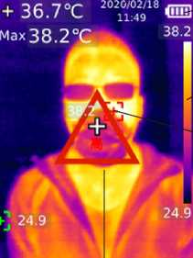
8

7
2
3
10

1

4
6

8

Item | Description | Item | Description
1 | Centre point temperature | 6 | High temperature alert sign
2 | Maximum temperature | 7 | Maximum temperature point
3 | Self-calibration | 8 | Temperature bar
4 | Minimum temperature point | 9 | Battery status
5 | Main menu | 10 | Date and time

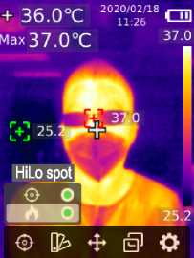
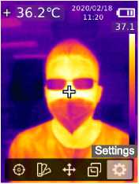
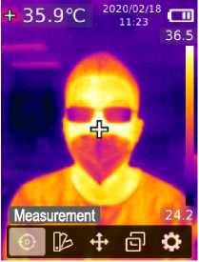

Main menu Sub menu Settings menu

3. Menu

3.1 Turn ON / OFF
Press and hold the power button for 3 seconds to turn on/off.

After the product starts the shutdown procedure, it takes 5 to 6 seconds. Please try to avoid turning on and off the product continuously to avoid damage.

3.2 Measurement
Setting the measurement control.
1. Press the SET button to open the main menu.
2. Press the left/right button to select the option.
3. Press the SET button to enter the Measurement menu.
4. Press the up/down button to select Centre Spot, Hi/Lo Spot or both.
5. Press the SET button to turn on/off Centre Spot, Hi/Lo Spot or both.
6. Press the return button to exit.

3.3 Palette
To set your desired pallet follow the instructions below.
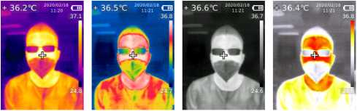

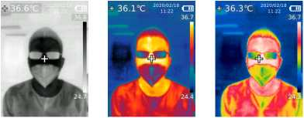

1. Press the SET button to open the main menu.
2. Press the left/right button to select the Palette option.
3. Press the SET button to enter the Palette menu.
4. Press the up/down button to select the desired palette.
5. Press the SET button to apply the palette.
6. Press the return button to exit.

3.4 Point Temperature
You can set 1, 2 or 3 point temperatures follow the instructions below.
1. Press the SET button to open the main menu.
2. Press the left/right button to select the Point Temperature option.
3. Press the SET button to enter the Point Temperature menu.
4. Press the up/down button to select the desired point.
A. Press the SET button to turn on the point and enter the thermal imaging page
Press the left/right/up/down button to move the point
Press the SET button to confirm and read the temperature of the current point.
B. Press the SET button to turn off the point.
Press the back button to exit.
5. Press the SET button to apply the palette.
6. Press the back button to exit.

3.5 Image Mode
If fusion is selected, users can press the left/right buttons to select the desired blending ratio from 0% pure visual light image, 25%, 50%, 75% and 100% pure infrared image.

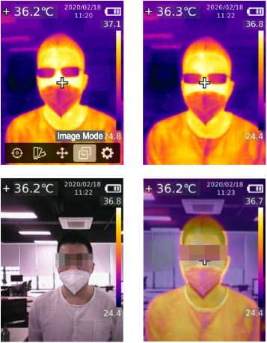

1. Press the SET button to open the main menu.
2. Press the left/right button to select the Image Mode option.
3. Press the SET button to enter the Image Mode menu.
4. Press the up/down button to select the desired mode from Thermal (infrared image), Digital (visual light image), and Fusion (image blending).
5. Press the SET button to apply the mode.
6. Press the back button to exit.

3.6 Settings
The setting consists of the following sub menus, to enter the Settings menu following the instructions below: -
- Language.
- Date and Time.
- Temperature unit.
- Hi/Lo Alert.
- Measurements.
- Display brightness.
- Auto power off.
- USB mode.
- Auto save
- System settings
1. Press the SET button to open the main menu.
2. Press the left/right button to select the Settings option.
3. Press the SET button to enter the Setting.

3.6.1 Language
You can select between English and Chinese.
1. Press the up/down buttons to select Language submenu.
2. Press the up/down buttons to select English or Chinese.
3. Press the SET button to confirm
4. Press the return button to exit.

3.6.2 Date and Time
To set the date and time follow the instructions below.
1. In the settings menu, press the up/down buttons to select the Date and Time option.
2. Press the set button to enter the Date and Time sub menu.
3. Press the left/right button to select the parameter to be adjusted.
4. Press the SET button to enter the parameter adjustment state.
5. Press the up/down buttons to increase or decrease the value.
6. Press the SET button to save the setting and return to the other parameters.
7. Press the return button to exit.

3.6.3 Temperature
To set the temperature value follow the instructions below.
1. In the settings menu, press the up/down buttons to select the Temperature unit.
2. Press the set button to enter the Temperature sub menu.
3. Press the up/down buttons to select °C or °F.
4. Press the SET button to confirm.
5. Press the return button to exit.

3.6.4 HI/LO Temperature Alert
To set the HI/Lo temperature alert follow the instructions below.
1. In the settings menu, press the up/down buttons to select the Hi/Lo Alert.
2. Press the set button to enter the Hi/Lo Alert sub menu.
3. Press the up/down buttons to select desired option.
4. Select Hi or Lo to set the desired temperature.
5. Select the other options to turn the alert on or off
6. Press the return button to exit.

3.6.5 Measurements
To set the Measurements follow the instructions below.
1. In the settings menu, press the up/down buttons to select the Measurements.
2. Press the set button to enter the Measurements sub menu.
3. Press the up/down buttons to select Emissivity or Temperature Compensation.
4. Press the SET button to enter the parameter adjustment state
5. Press the up/down button to increase or decrease the value.
6. Press the SET button to save the current setting
7. Press the return button to exit.

Note: For emissivity values of common materials, please refer to the Common Emissivity.

3.6.6 Display Brightness
To set the display brightness follow the instructions below
1. In the settings menu, press the up/down buttons to select the Display Brightness.
2. Press the set button to enter the Display Brightness sub menu.
3. Press the up/down buttons to select desired brightness level Low, Medium, or High.
4. Press the SET button to confirm.
5. Press the return button to exit.

3.6.7 Auto Power Off
To set the auto Power OFF follow the instructions below.
1. In the settings menu, press the up/down buttons to select the Auto Power Off.
2. Press the set button to enter the Auto Power Off sub menu.
3. Press the up/down buttons to select desired option 5 Minutes, 10 Minutes, 30 Minutes and OFF.
4. Press the SET button to confirm.
5. Press the return button to exit.

3.6.8 USB mode
To set the USB mode follow the instructions below.
1. In the settings menu, press the up/down buttons to select the USB Mode.
2. Press the set button to enter the USB Mode sub menu.
3. Press the up/down buttons to select USB Disk or USB Camera.
4. Press the SET button to confirm.
5. Press the RETURN button to exit.

3.6.9 Auto Save
To set the auto save follow the instructions below.
1. Press the up/down buttons to select the Auto Save in the settings menu.
2. Press the set button to enter the Auto Save sub menu.
3. Press the up/down buttons to select Yes or No.
4. Press the SET button to confirm.
5. Press the RETURN button to exit.

Note: Do not remove or insert the SD card in saving pictures. It is recommended to save no more than 1000 pictures, so as not to affect the response speed of the product. When the number of pictures exceeds 1,000, please clean up the SD card in time

3.6.10 System Settings
To see the system settings, follow the instructions below. This parameter contains the following information
- Device Information
- Factory reset
- Format Sdcard

To enter System Settings submenu:
1. In the settings menu, Press the up/down button to select the System Settings.
2. Press the SET button to enter the System Settings submenu

Device Information
1. In the settings menu, press the up/down buttons to select Device Information.
2. Press the set button to enter the Device Information.
3. You will see
Version: V1.0.10
Capacity: 513MB
Free: 373MB
5. Press RETRUN button to System setting Menu.
6. Press RETRUN button to Setting Menu.
7. Press RETRUN button to Main Menu.
8. Press RETRUN button to exit.

Factory Reset
1. In the Systems Settings menu, press the up/down buttons to select Factory Reset.
2. Press the set button to enter the Factory Reset.
3. Select yes or no.
4. Press the SET button to confirm (Note default language is Chinese)
5. Press RETRUN button to System setting Menu.
6. Press RETRUN button to Setting Menu.
7. Press RETRUN button to Main Menu.
8. Press RETRUN button to exit.

Format SD Card
To format an SD card, follow the instructions below.
1. In the Systems Settings menu, press the up/down buttons to select Format sdcard.
2. Press the set button to enter the Format sdcard.
3. Select yes or no.
4. Press the SET button to confirm
5. Press RETRUN button to System setting Menu.
6. Press RETRUN button to Setting Menu.
7. Press RETRUN button to Main Menu.
8. Press RETRUN button to exit.

Note: When formatting the SD card, please do not remove it or perform other operation to avoid program errors.

This mode allows users to realise real-time image projection after connecting to a PC.

4. Operating Instructions
For human body temperature checking please see our quick reference guide.

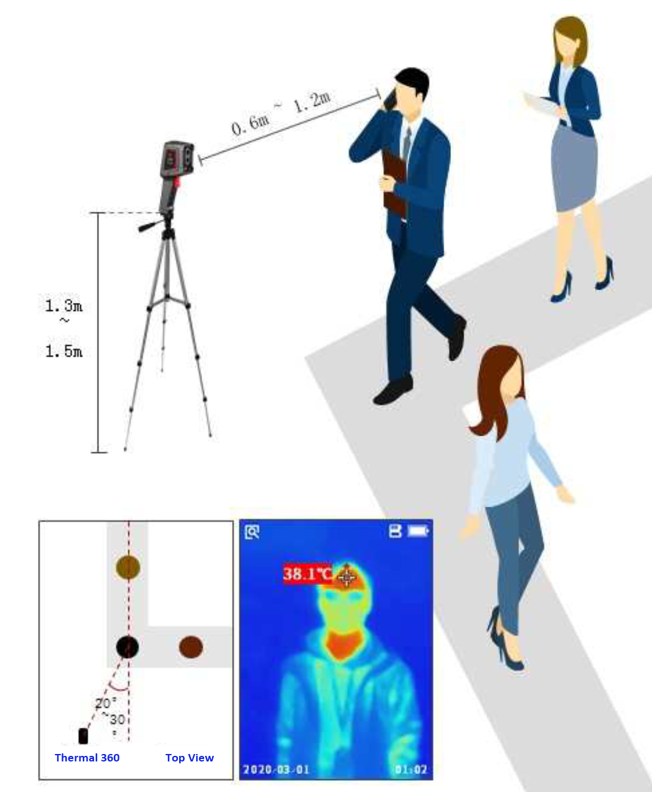

4.1 Image Capture
1. Pull and release the trigger to capture an image.
2. In the manual save mode, press the left/right button to discard or save the image, and press the SET button to confirm or the back button to return.
3. In the auto save mode, the image will be saved automatically.

Note: Images can only be saved if an SD card is installed

4.2 View Image
1. Press the replay button to enter the gallery interface
2. Use the up/down/left/right button to select the desired image.
3. Press the SET button to view the image in full screen mode.
4. Press the SET button in full screen mode to delete the image or view its information

Note: Do not remove or insert the SD card in viewing images

4.3 Temperature Compensation
To adapt to different environments and places, manual temperature compensation is available. For the specific setting method, please refer to 5.5.5 Measurements

4.4 Flashing/Warning Lights
Press and hold the flashlight button for 3 seconds to turn on/off the LED light. When the temperature alert is on and the measured temperature exceeds the set temperature range, the LED light will flash.

Note: When the flashlight is on, please do not point to the eyes of people or animals.

4.5 USB Communication and Image Projection
1. Download and install the PC software (refer to UNI-T Documents Download Operation Guide
2. Connect the USB cable to the PC
3. Set the USB mode to USB Disk to browse pictures and analyse data through the PC software; set the USB mode to USB Camera to realize real-time image projection through the PC software
4. Regarding the usage of the PC software, retrieve the Software User Manual from the Help option of the operation interface

4.6 SD Card
This device supports Micro SD card (TF card) to store images, to avoid affecting the operating speed of the device, please copy the backup data regularly and clean up the SD card in time. To avoid causing abnormal data on the SD card, do not insert or remove the SD card repeatedly. Try to remove and insert the SD card when the device is turned off.

The removable image memory devices can be cleaned by deleting the images from the device using the device or by removing the memory device and using a PC to access and delete the stored images.

Note that the removable memory device is not sanitised by the device. Data may still be recoverable by various data recovery methods. Numerous third-party tools are available that may be used to permanently wipe the data from the memory device.

Images stored on the internal eMMC device can be deleted through the device interface. The camera firmware does not sanitize the internal memory after deletion or provide a method to do so.

4.7 Charging
Please use a safety-certified 5V/1Aor 5V/2A power adapter for charging. Do not turn off the product easily during charging. If shutdown or restart is needed, please unplug the Type-C power cord, and disconnect the power supply first

- INSPECTION and MAINTENANCE
Use a wet cloth or weak soap solution to clean the outer shell of the device. Do not use abrasives, isopropyl alcohol, or solvents to clean the outer shell, lens, or window.

6. Common Emissivity.

Material | Emissivity | Material | Emissivity
Wood | 0.85 | Black paper | 0.86
Water | 0.96 | Polycarbonate | 0.80
Brick | 0.75 | Concrete | 0.97
Stainless steel | 0.14 | Copper oxide | 0.78
Tape | 0.96 | Cast iron | 0.81
Aluminium plate | 0.09 | Rust | 0.80
Copper plate | 0.06 | Gypsum | 0.75
Black aluminium | 0.95 | Paint | 0.90
Human skin | 0.98 | Rubber | 0.95
Asphalt | 0.96 | Soil | 0.93
PVC | 0.93

7. Warranty
Evolve guarantees that the product is free from any defect in material and workmanship within one year from the purchase date. This warranty does not apply to damage caused by accident, negligence, misuse, modification, contamination, or improper handling. The reseller shall not be entitled to give any other warranty on behalf of Evolve. If you need warranty service within the warranty period, please contact your seller directly.

Evolve will not be responsible for any special, indirect, incidental, or subsequent damage or loss caused by using this device

8. AFTER-SALES SERVICE
Please contact your local supplier/installer.

Original Equipment Manufacturer  Evolve Autogate Products HK Limited.  Flat C, 3rd floor, Lladro Building,  No.72 Hoi Yuen Road,  Kwun Tong,  Kowlong  Hong Kong | European Service Centre  Willings Services Limited  Unit 5,  Kenyons Yard  Weyhill Road  Andover  Hampshire  SP10 3NP

9. SPARE PARTS
Please refer to the spare parts manual available from EVOLVE.

9.1 Recommend Spare Parts
To enable a speedy repair, we recommend that the following items are held on site. Quantity is based on 1 – 5 guns.

USB + charger

10. TECHNICAL SPECIFICATIONS

Sensor | UFPA
Temperature range | 30°C~45°C
Measurement resolution | 0.1°C
Accuracy | ±0.5°C (at 25°C ambient temperature)
Optimal measuring distance | 1 meter
Response time | W500ms
IR resolution | 19,200 pixels (160 x 120)
Product size (Lx Wx H) | 236mm x 75.5mm x 86mm
Display type | 2.8" TFT LCD
Display resolution | 320 x 240 pixels
Battery | 3.7V/5000mAh rechargeable Li-ion battery
Auto power off | 5 minutes, 10 minutes, 30 minutes, off (default: 30 minutes)
Battery life | \6 hours
Charging time | W5 hours
Charging voltage/current | 5V/2A
Image storage | Micro SD card
Transportation/ Storage environment | -20°C~60°C (Y°F~140°F), <85% RH (non-condensing)
Operating environment | 15°C~30°C (59°F~86°F), <85% RH (non-condensing)
Operating altitude | W2000m
Standard accessories | User manual, USB cable, 16GB Micro SD card
Pixel size | 12pm
Color palette | Iron, Rainbow, white Hot, Red Hot, Black Hot, Lava, Rainbow HC
Infrared spectral band | 8pm~14pm
Field of view (FOV) | 56° (H) * 42° (V)
Spatial resolution (IFOV) | 6 m rad
Thermal sensitivity (NETD) | <50mK
Frame rate | <9Hz
Temperature measurement display | Centre point temperature, high temperature tracking (default)
Image format | BMP
Image mode | Thermal, Digital (visual light image), Fusion
Point temperature measurement | In addition to the centre point, 3 points can be added.
Certifications | -CE (EN 61326-1:2013, EN 61326-2-2:2013, EN 61326-2-3)  -RoHS

- References

11.0 ESP documents

Document No. | Title

11.1 Statutory documents

Document No. | Title

11.2 Abbreviations
The following abbreviations are created:
a. within this document.
b. from published sources.

Abbreviation | Description | Source
ESP | Evolve Security Products Limited | a

11.3 Definitions
The following topic specific definitions are created:
a. within this document.
b. from published sources.

Term | Definition | Source
 | Mandatory symbol is used to identify something that MUST be followed. | a
 | Danger symbol is used to identity a hazardous situation which, if not avoided, will result in serious personal injury. | a
 | Caution symbol is used to identity a hazardous situation which, if not avoided, could result in minor or moderate injury. | a
Centre Spot | Centre point measurement | a
Hi/Lo Spot | Maximum and minimum temperature spots | a

11.4 Requirements owner

Paragraph Number | Owner
All | Andy Brown

11.5 History

Editions | Date | Changes | Author
00 | 18/02/2017 | First draft | AB

APPENDIX A – CE Certificate

